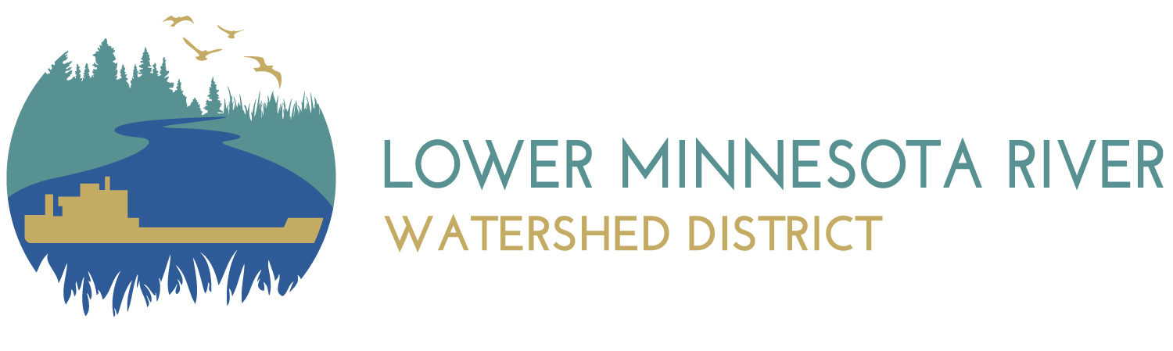

Lower Minnesota River Watershed District

7:00 PM - Wednesday, October 9, 2024

Carver County Government Center

602 East Fourth Street, Chaska, MN 55318

Please note the meeting will be held in person at the Carver County Government Center on the Wednesday, October 9, 2024. The meeting will also be available virtually using this [link](https://lowerminnesotariverwatersheddistrict.my.webex.com/lowerminnesotariverwatersheddistrict.my/j.php?MTID=m00d7e7ecbbcb3ba3a43fec68efdd47f1).

|  |  |
| --- | --- |
| **Agenda Item** | **Discussion** |
| 1. Call to order | 1. Roll Call |
| 1. Citizen Forum | *Citizens may address the Board of Managers about any item not contained on the regular agenda. A maximum of 15 minutes is allowed for the Forum. If the full 15 So are not needed for the Forum, the Board will continue with the agenda. The Board will take no official action on items discussed at the Forum, with the exception of referral to staff or a Board Committee for a recommendation to be brought back to the Board for discussion or action at a future meeting.* |
| 1. Approval of Agenda | 1. Additions, Corrections, and Deletions to Agenda |
| 1. Public Hearings & Presentations | 1. Report from Scott Sparlin on Water Storage activities 2. LMRWD work plan quarterly update (Q3 2024) 3. 2025 LMRWD work plans |
| 1. Consent Agenda | *All items listed under the consent agenda are routine by the Board of Managers and will be enacted by one motion and an affirmative vote of a majority of the members present. There will be no separate discussion of these items unless a Board Member or citizen request, in which event, the items will be removed from the consent agenda and considered as a separate item in its normal sequence on the agenda.*   1. Approve Minutes September 18, 2024, Regular Meetings 2. Receive and file September 2024 Financial report 3. Presentation of Invoices for payment    * 1. Clifton Larson Allen (CLA) – Financial services through September 2024      2. TimeSavers Off Site Secretarial – Preparation of August 21, 2024, meeting minutes      3. Rinke Noonan, Attorneys at Law – August 2024 legal services for permit fee development, Area #3 and general services      4. Daniel Hron – November 2024 office rent      5. US Bank Equipment Finance – October 2024 copier lease payment      6. Young Environmental Consulting Group, LLC – September 2024 technical, and Education & Outreach services      7. Naiad Consulting, LLC – September 2024 administrative services, mileage & expenses      8. 106 Group - Archeological survey work for Area #3 (#3193-3036-1)      9. 106 Group - Archeological Field work for Area #3 (#3193-2883-12)      10. Bolton & Menk, Inc. – Engineering services related to Vernon Avenue      11. MN Department of Administration – invoice for publication of Request for Qualifications for Government Relations Consultant      12. Star Tribune – Invoice for Publication of Budget Hearing Notice      13. 4M Fund – August 2024 fund service charges 4. Report from the Citizen Advisory Committee 5. LMRWD Personnel Committee agenda and minutes    * Personnel Committee – March 26, 2024    * Personnel Committee – April 10, 2024    * Finance Committee – September 3, 2024 6. Receive and authorize distribution of September 2024 ‘Geomorphic and Habitat Assessments of Trout Streams’ report 7. Approve Cost Share for 402 Broadway Street N., Carver, MN |
| 1. Permits | 1. Metropolitan Airport Commission (MAC) Municipal Local Government Unit (LGU) Permit (Surface Water Management Plan and Ordinance Controls Review) 2. Minnesota River Greenway Bridge (LMRWD No. 2023-010) 3. CenterPoint Energy (CPE) Xenwood Avenue and West 125th Street (LMRWD No. 2024-018) |
| 1. Action Items | 1. Award bid for Spring Creek 2. Update to LMRWD By-laws |
| 1. Board Discussion Items | 1. Standing meetings 2. 2025 Legislative Agenda |
| 1. Information Only | 1. Dredge Management 2. Study Area #3 3. State of the Minnesota River Listening Session 4. LMRWD Permit Program Summary |
| 1. Communications | 1. Administrator Report 2. President 3. Managers 4. Committees 5. Legal Counsel 6. Engineer |
| 1. Adjourn | Next meeting of the LMRWD Board of Managers is Wednesday, November 6, 2024. (Please note change from the third Wednesday) |

Upcoming meetings/Events

*Managers are invited to attend any of these meetings. Most are free of charge and if not the LMRWD will reimburse registration fees.*

* Metro Watersheds – Tuesday, October 22, 2024, 7:00 pm, Capitol Region Watershed District offices, 595 Aldine, St. Paul, MN
* [Water Resource Conference](https://click.ecommunications2.umn.edu/?qs=8907c2e8cf8858184188fdba2a53092f47d47b63a4758813b1213165ca8fde8cf4d19ecdfc1cb9217d87bd63cae9d8dca28de77ee2f58e96) – October 15 & 16, 2024, 8:00 am to 5:00 pm, St. Paul River Centre, 175 West Kellogg Boulevard, St. Paul, MN
* [Upper Mississippi Waterway Association Annual Meeting](https://umwa.net/annual-meeting/) – Thursday, October 17, 2024, 6:00 pm, Lilydale Pool & Yacht Club
* [Minnesota Stormwater Seminar Series](https://docs.google.com/forms/d/e/1FAIpQLSdKO2Y7fvni7vwMUn7LB1he-0Sb-15VrtxvPeem8CJuVGjnsw/viewform) – October 23, 2024, 10:00 am, in-person at St. Anthony Falls Laboratory Auditorium, 2 Third Avenue SE, Minneapolis and virtual on [Zoom](https://romi8ydab.cc.rs6.net/tn.jsp?f=001Nh_-nfRKO60Qa3DiaTNCd0U-8btn835PdRAtjEVUOddClu-9Xv08MVuUqEO7Qemir7alBidDLaw-0Guv5qnw2bxCsW7vV41ROFckBX5WppVEAHGLj3kKIOdLJ-ca5pwq7TKg1D4ThzM-M4ss69aEa3DpWp9_YY7oeYAd0Gx3KqCIaaea4TZKpQ==&c=40c9uNKZssBIrIQc-h4V2I4wlBK64oSriSgHnBay0_hivHemcGSVvA==&ch=gtfORoC4u_CwQvATqzeyjtNNwL7k4ZBqJVfdgPseZSXQZ0zp8s1Naw==) **(note: if you attend in person, there is usually an opportunity for a tour of the St. Anthony Falls Lab)**
* For Love of a River Revival – Thursday, October 24, 2024, 6:00 – 8:00 pm, Treaty Site History Center, 1851 N, Minnesota Avenue, (Hwy, 169), St. Peter, MN (see flyer attached to Administrator Report)
* [BWSR Academy](https://links-2.govdelivery.com/CL0/https:%2F%2Fbwsr.state.mn.us%2FBWSR_Academy/1/01010191568fd145-f1b63582-a578-475b-958c-a4ca80156ba4-000000/B1EPmE3pU3MB48aNlLsRo9Gq0pWFDy08ESY85oacSR8=366) – October 29 through October 31, 2024, Cragun’s Conference Center, 11000 Cragun’s Drive, Brainerd, MN
* LMRWD Citizen Advisory Committee meeting – Tuesday November 12, 2024 4:30 pm, virtual on Webex
* [MN Watershed Annual Conference](https://www.mnwatersheds.com/annual-conference) – December 4 through December 6, 2024, Grandview Lodge, 23521 Nokomis Avenue, Nisswa, MN

**For Information Only**

* **WCA Notices**
  + Scott County, City of Savage – Notice of Application – CSAH 16 (McColl Drive)
  + Hennepin County, City of Bloomington – Notice of Application – DNR State Trail, Minnesota River Valley
* **DNR Public Waters Work permits**
  + Scott County, City of Shakopee – Temporary Appropriation for construction dewatering for Blue Lake Dig Line by Xcel Energy
* **DNR Water Appropriation permits**
  + Scott County, City of Shakopee – Reinstatement of permit for Biff’s
  + Scott County, City of Savage – Reinstatement of permit for Superior Minerals
* **Well Head Protection Plans**
  + Notice of intent – the communities of Bloomington, Chanhassen, Eden Prairie, Edina, Hopkins, Minnetonka, Richfield, and Saint Louis Park intend to develop a regional, multi-community wellhead protection plan for our shared groundwater resources.