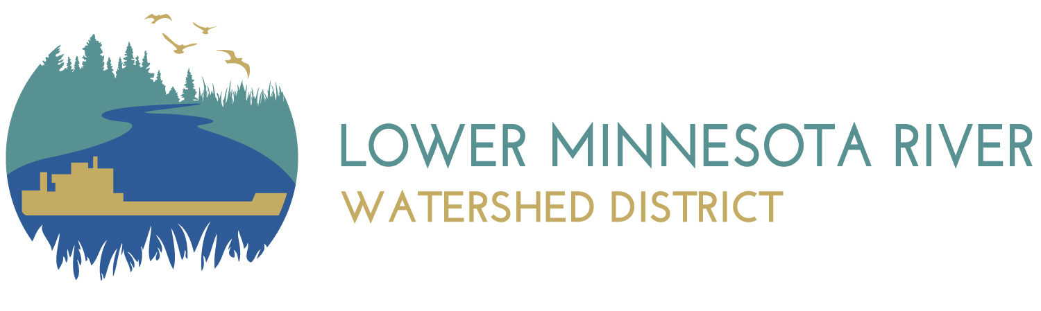

Executive Summary for Action
Lower Minnesota River Watershed District Board of Managers Meeting
Wednesday, September 15, 2021

Agenda Item
Item 6. H. Tour of LMRWD Project - Update
Prepared By
Linda Loomis, Administrator
Summary
We have a date for the tour! Saturday, October 2, 2021. And a route of projects. Staff will lead a discussion of other logistics at the meeting.
Attachments
No attachments
Recommended Action
No action recommended

