Watershed Outlet Monitoring Program

Willow Creek Station

Burnsville, MN

Quarterly Report

Preliminary Data

January – March 2007

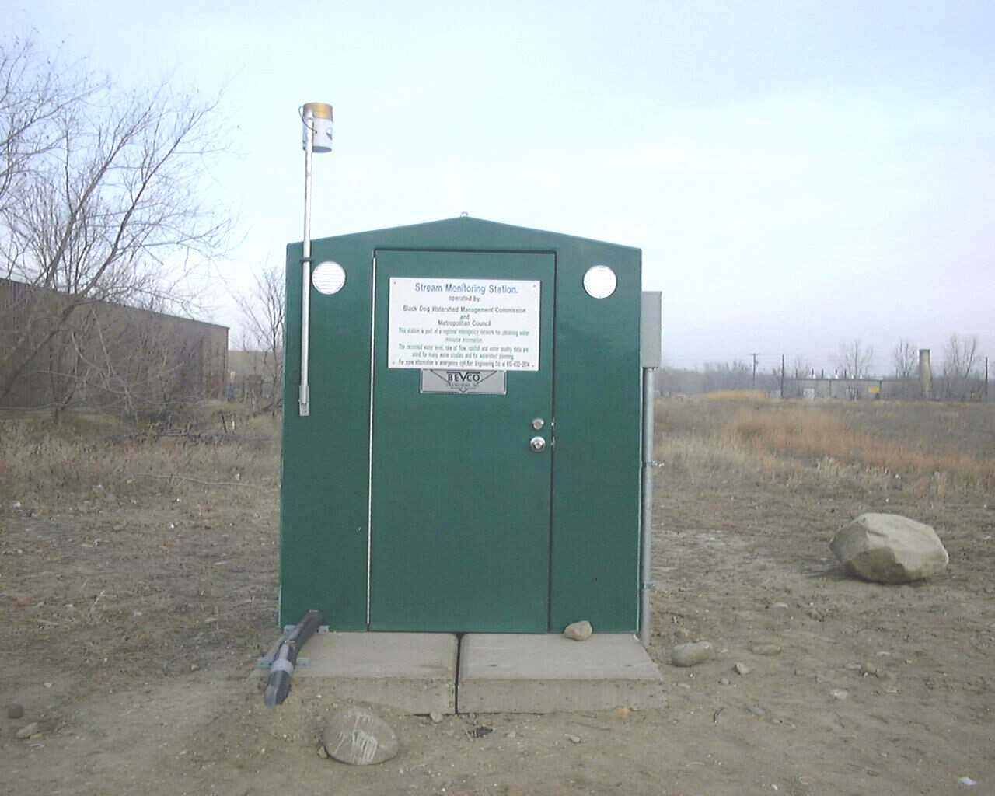

Prepared By: Dakota County Soil and Water Conservation District

Prepared For: Lower Minnesota River Watershed District

April 2007


Introduction

The Willow Creek WOMP site, located in Burnsville behind the Menards on Hwy. 13, has been in operation since 1999. The Willow Creek watershed drains more than 5,000 acres of various types of land uses including residential, vacant/agricultural, and commercial properties (Appendix A). This report summarizes the results of flow, precipitation, and water quality for the 1st quarter of 2007. This data is preliminary and is subject to change until the Metropolitan Council submits the final report for this period.

Flow and Precipitation

Average flow in Willow Creek was 2.99 cubic feet per second (cfs) or 1.93 million gallons per day (mgd) (Table 1). The rain gauge was not activated until 3/13/07. A graph describing quarterly flow and precipitation results is also provided (Figure 1).

Table 1. Average flow and total precipitation at Willow Creek WOMP Station January – March 2007
Period | Average Flow (cfs/mgd) | Precipitation (inches) | *Average Monthly Precipitation, 1997-2006 (inches)
JANUARY | 1.54/1.00 | NA | 1.02
FEBRUARY | 0.40/0.26 | NA | 0.78
MARCH | 7.27/4.70 | 3.96 | 1.81
TOTAL QUARTER | 2.99/1.93 | 3.96 | 1.19
*Average monthly precipitation data obtained from the National Weather Service station located near the Willow WOMP site.

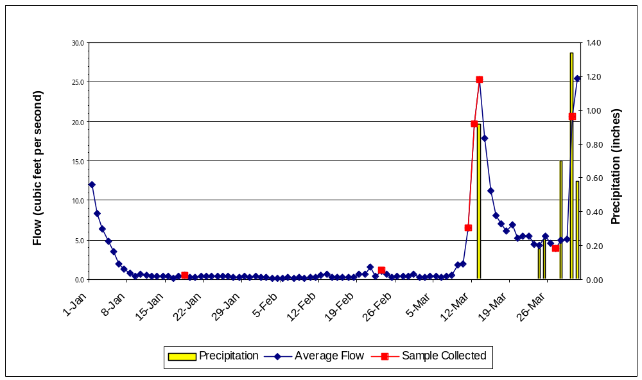

Figure 1. Flow and precipitation at Willow WOMP Station January – March 2007

Water Quality

Two event composite samples (3/11/07, 3/30/07) and three low flow grab samples were collected at the Willow WOMP Station during the 1st quarter 2007. Overall, water quality was good with nearly all parameters below the state standard (in compliance with standards) or near the ecoregion mean (Table 2).

Table 2. Average concentrations at Willow Creek WOMP Station October – December 2006 (for comparison purposes) and January – March 2007.
Parameter | 4th quarter 2006  Ave. Concentration | 1st quarter 2007  Ave. Concentration | Notes – 1st quarter results
Alkalinity | 273 mg/L  CaCO₃ | 197 mg/L CaCO₃ | Typical for freshwater; higher during low flow
Biological Oxygen Demand (BOD5) | 7.7 mg/L | 1.5 mg/L | Below eco-region mean
Cadmium | 0.04 ug/L | 0.04 ug/L | In compliance with state standard
Chloride | 123 mg/L | 158 mg/L | In compliance with state standard
Chlorophyll-a | 2.2 ug/L | 3.7 ug/L | Fair level
Chromium | 1.6 ug/L | 3.3 ug/L | In compliance with state standard
Conductivity | 1251 mMHOs | 1057 mMHOs | Above ecoregion mean, higher during low flow
Copper | 8.7 ug/L | 2.75 ug/L | In compliance with state standard
Fecal Coliform Bacteria | 498 CFU/100mL | 45 CFU/100mL | In compliance with state standard
Hardness | 483 mg/L  CaCO₃ | 321 mg/L CaCO₃ | Considered hard water; sometimes very hard during low flow
Lead | 0.6 ug/L | 0.6 ug/L | In compliance with state standard
Nickel | 8.2 ug/L | 9.6 ug/L | In compliance with state standard
Nitrogen Ammonia | 123.3 ug/L | 107.5 ug/L | In compliance with state standard
Nitrate + Nitrite | 0.76 mg/L | 0.30 mg/L | Above ecoregion mean
Phosphorus, Total | 0.2550 mg/L | 0.0938 mg/L | Below ecoregion mean
Suspended Solids | 9.3 mg/L | 11.75 mg/L | Below ecoregion mean; higher during some runoff events
Turbidity | 4.33 NTU | 6.75 NTU | In compliance with state standard
Zinc | 26.0 ug/L | 7.7 ug/L | In compliance with state standard
mg/L = milligrams per liter or parts per million (ppm)
ug/L = micrograms per liter or parts per billion (ppb)
mMHO = micromhos or micorseimens
CFU = colony forming units
NTU = nephelometric turbidity units
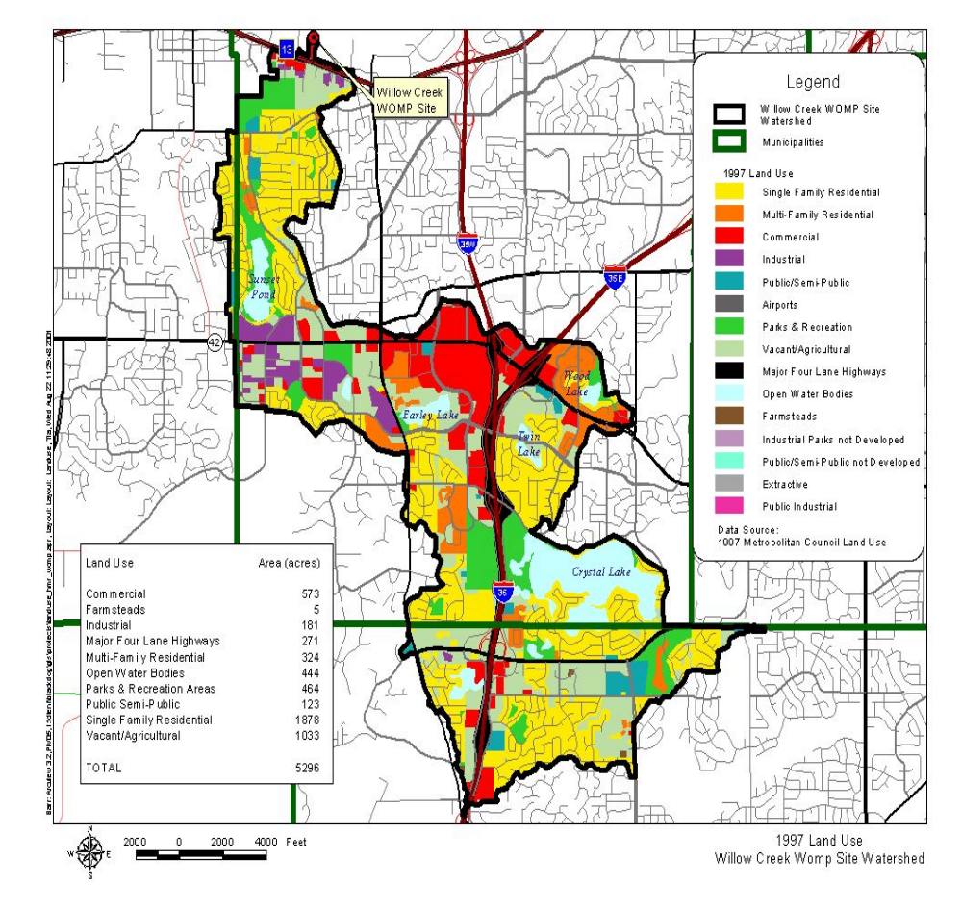Appendix A
Watershed and land use information provided by Metropolitan Council Environmental Services.

