Watershed Outlet Monitoring Program

Willow Creek Station

Burnsville, MN

Quarterly Report

Preliminary Data

July – September 2007

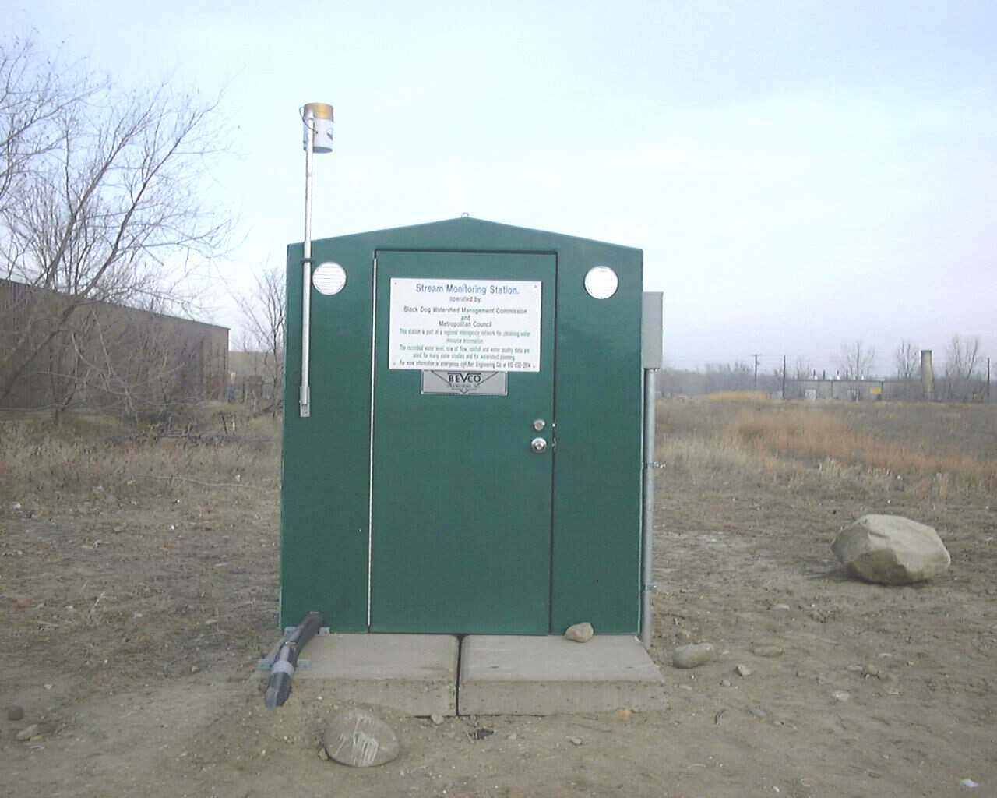

Prepared By: Dakota County Soil and Water Conservation District

Prepared For: Lower Minnesota River Watershed District

October 2007


Introduction

The Willow Creek WOMP site, located in Burnsville behind the Menards on Hwy. 13, has been in operation since 1999. The Willow Creek watershed drains more than 5,000 acres of various types of land uses including residential, vacant/agricultural, and commercial properties (Appendix A). This report summarizes the results of flow, precipitation, and water quality for the 3rd quarter of 2007. This data is preliminary and is subject to change until the Metropolitan Council submits the final report for this period.

Flow and Precipitation

Average flow in Willow Creek was 5.84 cubic feet per second (cfs) or 3.77 million gallons per day (mgd) (Table 1). A graph describing quarterly flow and precipitation results is also provided (Figure 1). It should be noted that the stage monitoring equipment was replaced in mid-September, which corresponds with a temporary decrease in stage observed in Figure 1.

Table 1. Average flow and total precipitation at Willow Creek WOMP Station July – September 2007
Period | Average Flow (cfs/mgd) | Precipitation (inches) | *Average Monthly Precipitation, 1997-2006 (inches)
JULY | 0.55/0.36 | 1.05 | 4.28
AUGUST | 11.97/7.74 | 8.41 | 4.29
SEPTEMBER | 4.82/3.12 | 3.12 | 3.00
TOTAL QUARTER | 5.84/3.77 | 12.58 | 11.57
*Average monthly precipitation data obtained from the National Weather Service station located near the Willow WOMP site.

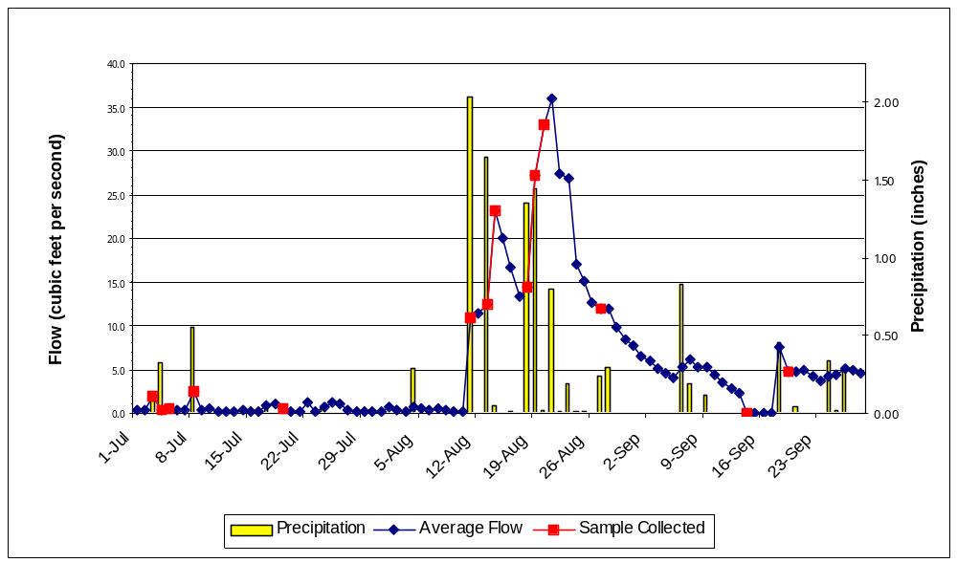

Figure 1. Flow and precipitation at Willow WOMP Station July-September 2007

Water Quality

Five event composite samples (7/3/07, 7/8/07, 8/11/07, 8/13/07, 8/18/07), one event grab sample (9/19/07-due to equipment failure), and three low flow grab samples were collected at the Willow WOMP Station during the 3rd quarter of 2007. Overall, water quality was good with most parameters below the state standard (in compliance with standards) or near the ecoregion mean (Table 2). However, several endpoints showed unusually elevated results (highlighted red). These results are likely due to the large number of August rain events and a reflection of the pollutant load present in the initial flush of storm water runoff.

Table 2. Average concentrations at Willow Creek WOMP Station January – June 2007 (for comparison purposes) and July-September 2007.

Parameter | 1st quarter 2007  Ave. Concentration | 2nd Quarter 2007 Ave. Concentration | 3rd Quarter 2007 Ave. Concentration | Notes – 3rd quarter results
Alkalinity | 197 mg/L CaCO₃ | 175 mg/L CaCO₃ | 91 mg/L CaCO₃ | Typical for freshwater; higher during low flow
Biological Oxygen Demand | 1.5 mg/L | 1.37 | 2.93 | Slightly above ecoregion mean due to a single elevated sample
Cadmium | 0.04 ug/L | 0.04 ug/L | 0.29 ug/L | In compliance with state standard
Chloride | 158 mg/L | 126 mg/L | 47 mg/L | In compliance with state standard
Chlorophyll-a | 3.7 ug/L | 4.2 ug/L | 9.9 ug/L | Fair level
Chromium | 3.3 ug/L | 10.9 ug/L | 4.5 ug/L | In compliance with state standard
Conductivity | 1057 mMHOs | 937 mMHOs | 454 mMHOs | Above ecoregion mean, higher during low flow
Copper | 2.75 ug/L | 5.4 ug/L | 7.6 ug/L | In compliance with state standard
Fecal Coliform Bacteria | 45 CFU/100mL | 240 CFU/100mL | 81 CFU/100mL | In compliance with state standard
Hardness | 321 mg/L CaCO₃ | 258 mg/L CaCO₃ | 129 mg/L CaCO₃ | Considered hard water; sometimes very hard during low flow
Lead | 0.6 ug/L | 1.8 ug/L | 5.0 ug/L | Exceeds state standard
Nickel | 9.6 ug/L | 6.6 ug/L | 7.7 ug/L | In compliance with state standard
Nitrogen Ammonia | 107.5 ug/L | 48.0 ug/L | 168.6 ug/L | Exceeds state standard
Nitrate + Nitrite | 0.30 mg/L | 2.21 mg/L | 0.30 mg/L | Above ecoregion mean
Phosphorus, Total | 0.0938 mg/L | 0.1136 mg/L | 0.1718 mg/L | Slightly above ecoregion mean
Suspended Solids | 11.75 mg/L | 50.2 mg/L | 104.1 mg/L | Above ecoregion mean
Turbidity | 6.75 NTU | 22.6 NTU | 20.8 NTU | In compliance with state standard
Zinc | 7.7 ug/L | 17.2 ug/L | 56.0 ug/L | In compliance with state standard
mg/L = milligrams per liter or parts per million (ppm)
ug/L = micrograms per liter or parts per billion (ppb)
mMHO = micromhos or microseimens
CFU = colony forming units
NTU = nephelometric turbidity units
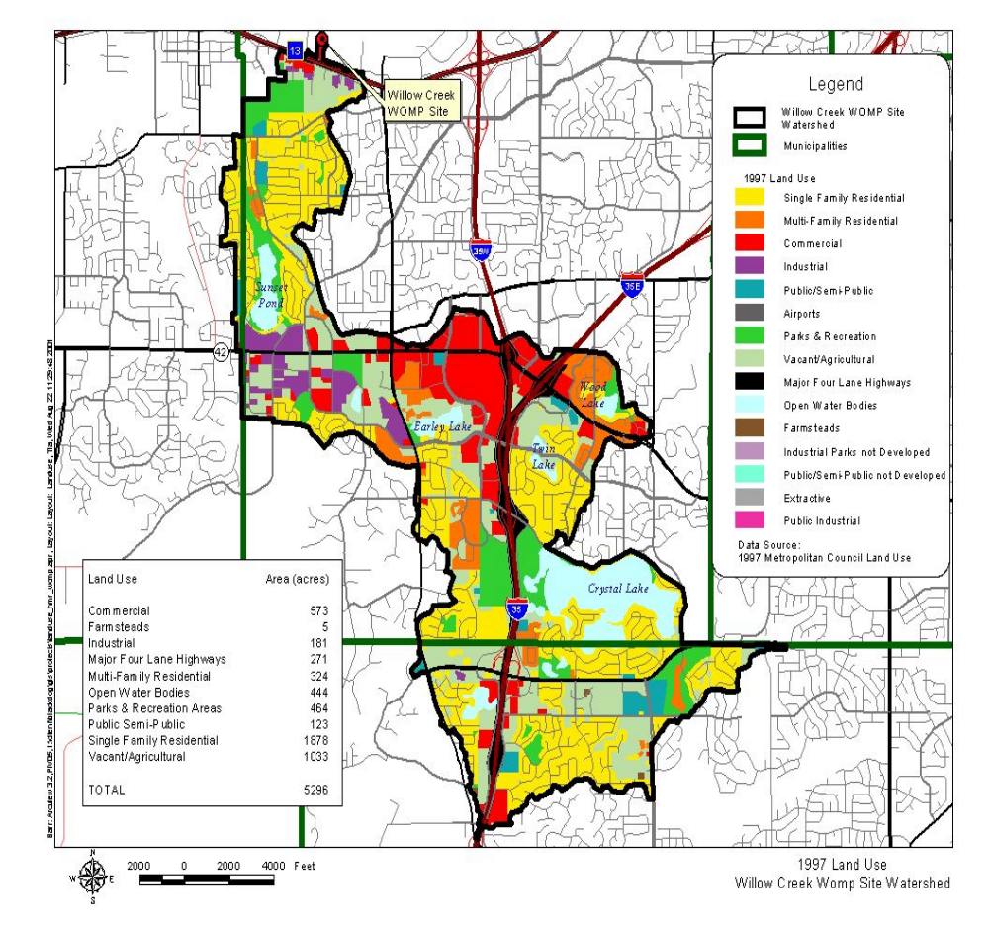Appendix A
Watershed and land use information provided by Metropolitan Council Environmental Services.

